
Appendix A

South Ribble Local Plan
Monitoring Report
Covering the period April 2017 – March 2018

Contents
Appendix A

1. Introduction 1

2. Summary 1

3. Progress on revised South Ribble Local Development Scheme (LDS) 3
Local Plan 2015 and Policy Map (Previously Site Allocations DPD) 4
Neighbourhood Plans 4
Gypsies, Travellers and Travelling Showpeople DPD 5
Supplementary Planning Documents 5
Overall Conclusion on Progress 5

4. Key contextual indicators for the Local Plan Performance Monitoring Framework 6
Spatial Portrait 6
Population 6
Population Profile 7
Unemployment 8
Deprivation 8
Designated Protected Sites 10
Trees and Hedgerows 10
Green space 10
Listed Buildings 10
Conservation Areas 10
Transport and Spatial Connectivity 11

5. Performance Monitoring Framework of the South Ribble Local Plan 2015 11

6. Monitoring Framework .............................21

Introduction
Appendix A

1.1 The Town and Country Planning (Local Planning) (England) Regulations 2012 updated the requirement to prepare Local Development Frameworks (LDFs), which were first introduced in the Planning and Compulsory Purchase Act 2004. In order to assess the effectiveness of the Local Development Framework policies, the regulations also require authorities to produce a Monitoring Report, (MR) which is to be prepared annually. The purpose of the MR is twofold. It will assess the implementation of the local development scheme (LDS) and the extent to which the policies in the local development documents are being successfully implemented.

1.2 This is the Fourteenth Monitoring Report to be published by the council and it covers the period 1 April 2017 to 31 March 2018. The Central Lancashire Core Strategy was adopted in July 2012, and a separate monitoring report will be produced to report on its monitoring framework and will be the fifth such report. The Local Plan was adopted in July 2015. This MR will report on the Indicators within the Local Plan. This MR will fulfil the following purposes:

- Report progress on the Local Development Scheme;
- Report key contextual indicators for the South Ribble Local Plan 2015;
- Report on core output indicators;
- Report on the South Ribble Local Plan Monitoring Framework 2015.

2. Summary

Monitoring Report recognises that monitoring impact and effect is a key part of the development planning process.

  - This MR covers five important areas;

- Reports progress on the South Ribble Local Development Scheme
- Identifies contextual indicators for the South Ribble Local Development Framework
- Reports on core output indicators;
- Reports on the Monitoring Framework of the South Ribble Local Plan (2015)
- Reports on the Monitoring Framework of the Central Lancashire Core Strategy (in a joint separate document).

  - There were two Local Development Schemes which covered this monitoring period, one published in April 2015 and also a revised version published in January 2018. This MR will report on milestones using the January 2018 LDS, as this is the most up to date.

2.4 This report suggests a number of contextual indicators for the Local Plan (2015) Monitoring Framework. Their purpose is to provide a broad picture of the social, economic and environmental circumstances that exist in the borough against which the output and effects of the Local Plan policies can be measured. They effectively establish a baseline position from which change can be measured and are selected to highlight key characteristics of South Ribble.
Demographic structure: Population growth
Population profile

Socio-cultural: Deprivation

Environmental: Designated protected areas
Trees and hedgerows
Green space

Housing and built Listed buildings
environment: Conservation areas

Transport and spatial Air Quality Management Areas
connectivity: Location
Demography

Appendix A

2.5 Some of the indicators cannot be updated on an annual basis as they are supplied by the Census with the next being due in 2021. From those that can, the following can be reported:

      - Unemployment levels are consistently below both the Lancashire and national average, and are decreasing;
- The population of the borough continues to rise slightly;

2.6 In relation to the Core output indicators, some key findings for the monitoring period 1 April 2017 – 31 March 2018 are:

- 64% of new dwellings were built on previously developed land compared to 56% last year. This is above the national target of 60%;
- The number of housing completions was 318 dwellings in 2017/18. This is below the annual housing requirement;
- There were 40 affordable dwellings completed in 2017/18, this is above the target of 30 as set out in the Central Lancashire Core Strategy.
- Our three parks with Green Flag status have retained the award.

2.7 The Central Lancashire Core Strategy indicators are reported on in a separate document.

Appendix A

3. Progress on revised South Ribble Local Development Scheme (LDS)

  - One purpose of the MR is to report on progress in the Local Development Scheme (LDS) in relation to the milestones within it and indicate whether any adjustment to the scheme is considered necessary.

  - The LDS included the preparation of the following Local Development Documents

- Central Lancashire Core Strategy/South Ribble Local Plan - Review
- Statement of Community Involvement
- Supplementary Planning Documents
- Community Infrastructure Levy Review

3.3 For more detail please see the full version of the latest revised LDS which is available to view on the council’s web site here.

3.4 The milestones for the preparation of these Development Plan Documents during the monitoring period are shown in the table below.

3.5 Progress in relation to each of the Local Development Plan Documents is as follows:

 | Central Lancashire Core Strategy/South Ribble Local Plan – Review | Statement of Community Involvement | Supplementary  Planning Documents | Community Infrastructure Levy Review
Jan-18 | Evidence Gathering including  Call for Sites | Preparation |  | Based on the stated intent in the 2017 Autumn Statement a CIL review will be subject to a further consultation by Government.
Feb-18
Mar-18 | Evidence Gathering including  Call for Sites | Consultation
Apr-18
May-18 | Evidence Gathering including  Call for Sites | Consider responses
Jun-18 | Evidence Gathering including  Call for Sites | Adoption
Jul-18 | Evidence Gathering including  Call for Sites
Aug-18 | Evidence Gathering including  Call for Sites
Sep-18 | Evidence Gathering including  Call for Sites
Sep-18 | Preparation of Issues & Options
Oct-18 | Preparation of Issues & Options
Nov-18 | Preparation of Issues & Options
Dec-18 | Issues & Options Public Consultation
Jan-19 | Issues & Options Public Consultation
Feb-19 | Review of Issues & Options
Mar-19 | Review of Issues & Options
Apr-19 | Review of Issues & Options
May-19 | Preparation of Preferred Options
Jun-19 | Preparation of Preferred Options
Jul-19 | Preparation of Preferred Options
Aug-19 | Six week consultation on Preferred Options
Sep-19 | Six week consultation on Preferred Options
Oct-19 | Review Preferred Options consultation responses and prepare responses to representations
Nov-19
Dec-19 | Preparation of Publication Document
Jan-20 | Preparation of Publication Document
Feb-20 | Publication Consultation |  | Evidence Gathering
Mar-20 | Publication Consultation |  | Preparation of SPDs
Apr-20 | Review publication stage and prepare responses to representations/ prepare for submission |  | Preparation of SPDs
May-20 |  |  | Preparation of SPDs
Jun-20 |  |  | Public Consultation
Jul-20 | Submission |  | Public Consultation
Aug-20 | Pre-hearing meeting with Inspector (8 weeks after submission, 6 weeks before examination) |  | Review consultation responses and prepare responses to representations
Sep-20 | Examination
Oct-20 | Inspector’s Report |  | Preparation of final SPDs
Nov-20 | Endorsement by Cabinet/Council  Adoption |  | Endorsement by Cabinet/Council  Adoption
Dec-20 | Publish Adoption Statement |  | Publish Adoption Statement
Appendix A

Central Lancashire Core Strategy/South Ribble Local Plan Review

3.6 Evidence gathering to inform the review of the Core Strategy and Local Plan is underway. However, the call for sites exercise is now scheduled for late summer 2018, so the milestones for production of this document which fall within the monitoring period have only partially been met. This is mainly due to unforeseen delays with appointing staff to the joint Central Lancashire Team.

3.7 The needs of Gypsies, Travellers and Travelling Showpeople will be incorporated into the reviews of the Central Lancashire Core Strategy and South Ribble Local Plan.

Statement of Community Involvement

3.8 Work on the production of a new Statement of Community Involvement has been delayed until the Central Team are in place. It is expected that work will commence in 2019.
Appendix A

Supplementary Planning Documents

3.9 There are 9 Supplementary Planning Documents which are currently adopted, 7 of these are Central Lancashire SPDs with 2 being South Ribble Documents.

- Affordable Housing
- Design
- Controlling re-use of Employment Premises
- Rural Development
- Access to Healthy Food (currently under review)
- Open Space and Playing Pitch
- Residential Extensions (South Ribble)
- Renewable and Low Carbon Energy (South Ribble).
- Biodiversity and Nature Conservation

3.10 The LDS does not indicate that any new SPDs will be produced. The need for new SPDs or review of existing SPDs will take place as the review of the Local Plan is carried out.

Overall Conclusion on Progress

3.11 Work on the Local Plan review has not fully met the milestones set out in the LDS. Once the Central Team are fully in place work can progress further.

3.12 There were no further milestones relating to the production of any other documents within the monitoring period covered by this report.

4. Key contextual indicators for the Local Plan 2015 Performance Monitoring Framework

Spatial Portrait

4.1 The borough of South Ribble is situated in the centre of Lancashire, and is immediately to the south of the River Ribble. It has excellent communication links from its location astride the north/south M6 motorway, and the main London to Glasgow railway. Connections are available to the M55, M61 and M65 motorways as well as the A6, A49 and A59 roads. Rail links are also available to East Lancashire, the Fylde, Greater Manchester and Merseyside. The borough is less than an hour’s drive from the airports at Manchester and Liverpool. The borough has an area of 44 square miles, with approximately 7,730 hectares of greenbelt land, which is approximately 68% of the total area.

Appendix A
Population

4.2 The population of the borough is estimated to be 110,400 (Source: Office National Statistics (ONS): Mid-Year Population Estimates 2017). The total population for the majority of the time has been rising over the last 30 years as shown in the following chart.

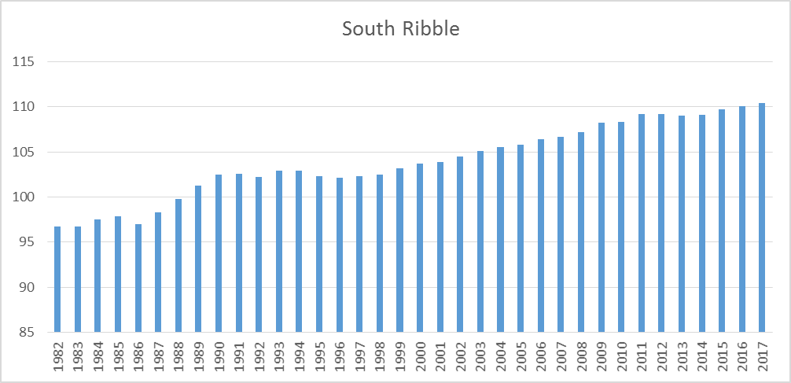
(Source: ONS - mid-year estimates)

4.3 It is projected to continue growing as shown below, although the projections are trend based and do not take into account the effects of strategic policy.

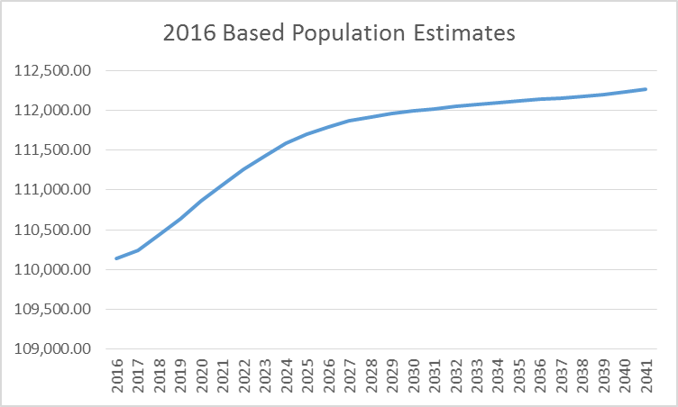
(Source: ONS: Subnational Population Projections)

4.4 Comparison with the mid-year estimates and the next census (2021) will show what the actual growth has been against the projected growth. A key issue for the Local Plan is to what extent spatial planning policies will impact population growth.

Population profile
Appendix A

4.5 At the time of the 2011 Census, the usual resident population of the borough was about 109,100 broken down into the following age groups.

South Ribble Compared with England & Wales

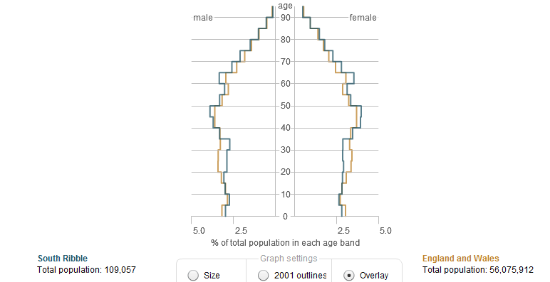
(Source: 2011 Census ONS - Crown copyright)

South Ribble – 2001 Compared with 2011 (outline shows 2001)
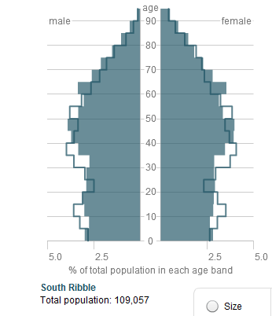
(Source: 2011 Census ONS - Crown copyright)

4.6 The most noticeable variations in the borough’s population from the national average are: fewer adults in the 20-34 age groups and more people in the 60-64 age group. The borough has had a younger than average population over the last 20 years, largely related to in-migration of young people in the new town era. Twenty years on this could account for higher proportions of pre-retired people i.e. those who came here in the 1970s and 1980s.

Unemployment
Appendix A

4.7 The following figures show the current unemployment rates (based on ONS count of Job Seekers Allowance claimants in the borough of working age 16–64), and compares the rate with Lancashire and the North West.

4.8 The current (December 2017) claimant rate is 0.5% in South Ribble, which is below the Lancashire rate of 0.8% and significantly below the North West rate of 1.0%.

Deprivation

4.9 The Indices of Multiple Deprivation (IMD) measure seven different aspects (or domains) of deprivation for lower level super output areas across England: Income, Employment, Health and Disability, Education, Skills and Training, Barriers to Housing Services, Living Environment and Crime. These are weighted and combined to create the overall IMD. Deprivation is reported down to Lower Super Output Areas (LSOAs); these are subdivisions of wards and contain a minimum of 1,000 people and 400 households. The Indices of Deprivation identifies concentrations of deprivation and it is important to note that not all deprived people live in deprived areas and, conversely, not everyone living in a deprived area is deprived. It is not a measure of affluence.

4.10 The indicators have been chosen because they represent different aspects of deprivation. A lack of deprivation does not necessarily equate to affluence. Therefore, the LSOAs with the highest ranks are not necessarily affluent, just less deprived. The English Indices of Deprivation 2015 rank South Ribble 229 out of 326 local authority areas in England. This indicates that the borough does not suffer from high levels of deprivation. Nonetheless, at a more detailed level, the indices show that there are small areas within the borough with problems related to deprivation. Two LSOA’s fall within the worst 10% most deprived areas of England. By comparison, South Ribble has twelve LSOAs in the best 10%.

4.11 The council, in conjunction with its partners across many agencies continues to work to address the deprivation issues. The map below shows deprivation levels across the Borough according to the Indices of deprivation 2015.

Deprivation Levels by Lower Super Output Area
Appendix A
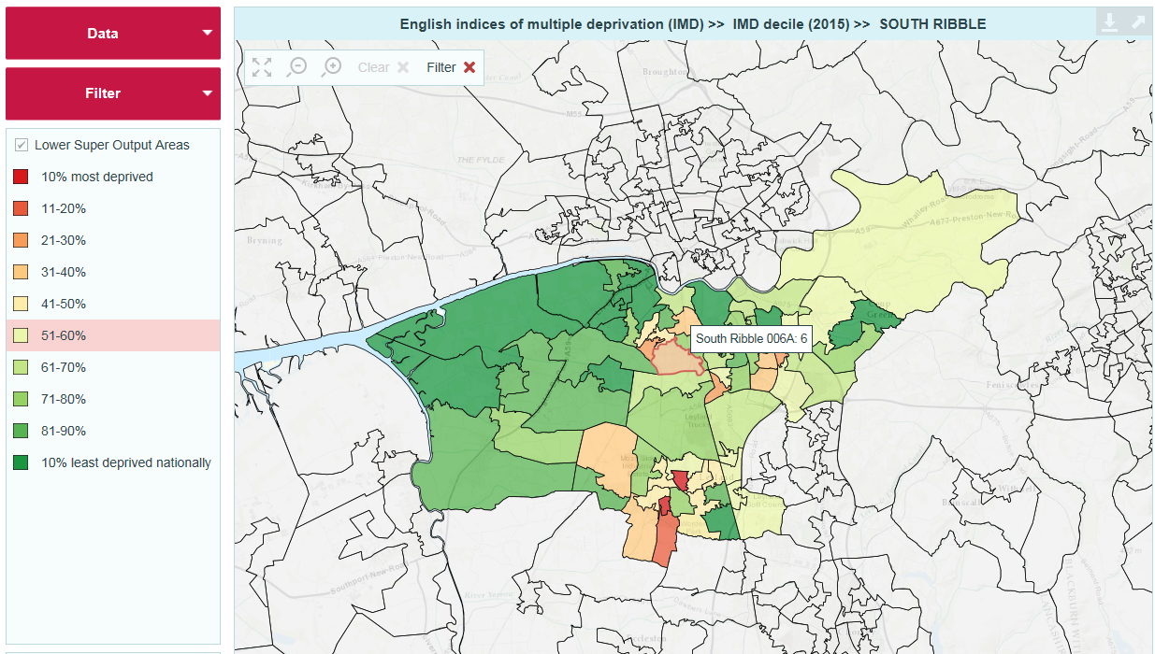
Source: Lancashire County Council

Designated protected sites

4.12 478.5 hectares or 4.1% of the borough is protected as Sites of Special Scientific Interest (SSSIs) or Local Nature Reserve etc. An objective of the Local Development Framework is to ensure that development does not harm protected sites and habitats. Work is completed on a Habitats Regulations Assessment to ensure protection of these important sites. This was published alongside the Central Lancashire Core Strategy and the South Ribble Site Allocations Partial Version document in November 2013.

Trees and hedgerows

4.13 Twenty seven areas or a total area of 231.6 hectares is protected as ancient woodland. 388 tree preservation orders (TPOs) were in force in the borough as of March 2018, protecting individual or groups of trees and woodlands. This figure does fluctuate as trees can be felled by storms, become unsafe or new designations can be put in place.

Green space

4.14 An Open Space and Recreation study was completed in July 2012 and includes an up-to-date audit of open space provision in the borough and provides a baseline for monitoring changes to the overall amount to inform the LDF process. The study identifies almost 730 hectares of open space in the borough. (Source: Open Space Study database 2012) This includes land in public and private ownership and land which has active or passive use. There is currently a new Open Space Study underway, which is due to be completed in 2018.

Listed Buildings
Appendix A

4.15 The borough has 144 entries on the listed buildings register as being of special architectural or historic importance. Two are grade I buildings of national interest, ten are grade II* buildings and the remainder grade II.

Conservation Areas

4.16 There are eight conservation areas in the borough and each has an appraisal and management plan. It is intended that these appraisals and management plans will be regularly reviewed and kept up to date. The Conservation Area Appraisals for each of the 8 Conservation Areas were published early in 2014. New Conservation Areas will be designated in the future where appropriate, in areas that merit such a designation.

Self-build and Custom Housebuilding Register

4.17 The Self-build and Custom Housebuilding Act 2015 placed a duty on all local authorities to keep a register so that an assessment of demand in the local area for this type of housebuilding can be made. This is the second reporting year for self-build and custom housebuilding. The headline data from the register shows that we have 14 applicants on the register (low demand) as at 31 March 2018 this has gone down by 1 when compared to the 2017 figure. Please see table below for further details:

Group/Individual | Area of Interest | No of Dwellings | Type of Dwelling | Plot  Size
Individual | South Ribble | 1 | Detached House | Unknown
Individual | Western Parishes | 1 | Detached House | Unknown
Individual | South Ribble | 1 | Detached House | Unknown
Individual | South Ribble | 1 | Detached House | 0.5ha
Individual | Leyland | 1 | Detached House | 0.5ha
Individual | South Ribble | 1 | Detached House | 0.5-1 acre
Individual | Leyland | 1 | Detached House | 1ha
Individual | South Ribble | 1 | Detached House | 0.25ha
Individual | South Ribble | 1 | Detached House | 0.25ha
Individual | South Ribble | 1 | Detached Bungalow | 0.25ha
Individual | Penwortham | 1 | Detached House | 1ha
Individual | South Ribble | 1 | Detached House | 0.125ha
Individual | South Ribble | 1 | Detached House | 0.013- 0.020ha
Individual | Longton | 1 | Detached House | Unknown

Transport and spatial connectivity

4.18 The borough of South Ribble is situated in the centre of Lancashire, and is immediately to the south of the river Ribble. It has excellent communication networks from its location astride the north/south bound M6 motorway and the main London to Glasgow railway line. Connections are also available to the M55, M61 and M65 motorways as well as the A6, A49 and A59 roads. Rail links are also available to East Lancashire, the Fylde, Greater Manchester and Merseyside. The borough is less than an hour’s drive from Liverpool and Manchester airports.

5. Performance Monitoring Framework of the South Ribble Local Plan 2015
Appendix A

5.1 The Local Plan (2015) Indicators within the Performance Monitoring Framework are monitored. These indicators are below and are considered necessary to accurately measure the effectiveness of policies within the Local Plan.

Level of Nitrogen Dioxide at the Air Quality Management Areas (AQMA)

Policy/Policies this contributes to - A1, A2, A3

5.2 There are currently five declared AQMA’s within the South Ribble area. All of the declared AQMA’s have been declared for the likely exceedance of the Nitrogen Dioxide annual mean objective of 40µg/m³. During this monitoring period Victoria Road in Walton-le-Dale (AQMA 2) is the only area that has exceeded the objective of 40µg/m^{3,} the other areas are slightly under the objective.

5.3 The five current AQMA areas are;

AQMA 1 - Cop Lane, Priory Lane, Penwortham
AQMA 2 - Victoria Road, Walton-le-Dale going into Preston
AQMA 3 - Tardy Gate/Brownedge Road, Lostock Hall
AQMA 4 - Station Road, Bamber Bridge
AQMA 5 - Turpin Green Lane/Golden Hill Lane, Leyland.

5.4 Due to the declaration of another AQMA (AQMA 5) the Council’s Air Quality Action Plan (AQAP) is in the process of being revised. The AQAP includes among other measures actions that will be taken via the development control process to enable a reduction in emissions and the promotion of alternative forms of travel around the borough.
The Air Quality Action Plan (AQAP) and more information regarding air quality in South Ribble is available here.

Changes to Road Traffic Congestion (Core Strategy Policy 3)

Policy/Policies this contributes to - A1, A2, A3

5.5 The Department for Transport (DFT) carries out traffic monitoring in the Central Lancashire area. The monitoring sites are in locations known to experience significant volumes of traffic. These will be monitored each year so will show any trends up or down.

5.6 The table below shows the 7 day average figures for each of the 6 locations across the South Ribble area.

South Ribble Data
Appendix A
Traffic Counts

Year | Location
Year | 1 | 2 | 3 | 4 | 5 | 6
2012 | 24495 | 26962 | 18337 | 39533 | 25083 | 34009
2013 | 24403 | 26841 | 18309 | 38889 | 25136 | 33899
2014 | 24671 | 26960 | 18831 | 39830 | 23103 | 31591
2015 | 24468 | 26661 | 17664 | 38558 | 24087 | 32836
2016 | 24238 | 26330 | 18217 | 39445 | 24872 | 33882
2017 | 24667 | 29287 | 18139 | 40504 | 24859 | 33762

Location of Monitoring Sites in South Ribble

1 A582 Penwortham Way, S of Lodge Lane, Farington Moss (CP 28720)
2 A6 London Way, N of B6230 (CP 18511)
3 A59 Liverpool Road, S of Hutton Roundabout (CP 56605)
4 A6 South Ribble Way, S of A582, Farington (CP 99554)
5 A6 Lostock Lane, W of M6 J29a, Bamber Bridge (CP 28555)
6 A59 Preston New Road, W of Cuerdale Lane, Samlesbury (CP 16566)

5.7 Locations 1, 2 and 4 above have shown a modest increase during the periods recorded. However locations 3, 5 and 6 have shown a slight decrease as shown in the table above. The overall increase on the 2016 figure is 4,234, it is thought that the reason for this is that the road works have been largely completed that have been taking place and development is continuing. It is expected that traffic levels will rise further overall as more new development occurs across South Ribble.

5.8 It is important that appropriate infrastructure is put in place to cope with the extra traffic associated with this development. It is also necessary to ensure that appropriate sustainable transport infrastructure is put in place as part of development, to try and reduce the number of cars on the road. We will continue to monitor traffic in South Ribble.

5.9 The Central Lancashire Highways and Transport Masterplan (March 2013) represents Lancashire County Council’s priorities for future investment in highways and transport across Central Lancashire and a delivery programme to 2026 which will see new road space built, public transport prioritised across key corridors into Preston and between Leyland and Chorley, and public realm improvements in city, town and local centres.

5.10 The description of Monitoring Sites above includes a 'Count Point' (CP) id for each location (e.g.CP28720). Traffic data from the year 2000 for these and all Count Points in Central Lancashire and nationwide can be viewed on the Department for Transport's website at; www.dft.gov.uk/traffic-counts.

Gross Affordable Dwellings Constructed (Core Strategy Policy 7)
Appendix A

Policy/Policies this contributes to - A1, B2, C1, C2, C3, D1, D2

5.11 There has been 40 affordable dwellings completed in the 2017/18 monitoring year, this exceeds the target of 30 as set in the Central Lancashire Core Strategy and is approximately 12.5% of the overall completion figure below at 5.2, which is an increase on the 2016/2017 figure of around 57%. We expect the number of affordable homes to increase in the future with more large permissioned sites contributing to their development. For more details please refer to the latest Housing Land Position Statement.

Value of Developer Contributions Collected (and spent on infrastructure priorities) (Core Strategy – Policy 2)

Policy/Policies this contributes to - A1, C1, C2, C3, C4, C5, D1, D2, G9, G10, G11, H1

S106 contributions collected | S106 contributions spent | CIL collected | CIL spent on 123 List | CIL transferred to Parish Councils
£1,148,204 | £605,392 | £553,388 | £223,000 | £24,033

5.12 The table above shows that during this monitoring period £1,148,204 S106 monies were collected and the capital expenditure funded from S106 monies was £605,392. The amount of CIL contributions collected during the monitoring year was £553,388 with £223,000 having been paid to Lancashire County Council for spending on infrastructure priorities. In addition £24,033 has been paid over to the relevant Parish Councils in accordance with the CIL regulations.

Net amount of sport, recreation and informal open spaces lost to other uses (Core Strategy Policy 18)

Policy/Policies this contributes to - A1, G1, G3, G4, G5, G6, G7, G8, G9, G10, G12, G13, H1

5.13 During this monitoring period there has been nil loss of sport, recreation and informal open spaces to other uses.

5.14 To enable the Enterprise Zone to be delivered at BAE Systems Samlesbury the Green Belt boundary was amended in accordance with policy ‘C5–BAE Systems, Samlesbury of the South Ribble Local Plan.

Quality rating of public open spaces

Policy/Policies this contributes to - A1, G7, G8, G9, G11, G12

5.15 75% of the public open spaces that have been assessed within the borough are rated as high quality. At the time of the next Monitoring Report an open space study that is currently taking place will have been published and this will provide more up to date information.

No reduction in range of uses within the boundary of the Capitol Centre
Appendix A

Policy/Policies this contributes to - B5

5.16 There has been no reduction in the range of uses within the boundary of the Capitol Centre during this monitoring period, however the unit that was occupied last year after being vacant for some time has now become vacant again so there is 1 vacant unit within the Capitol Centre (Use Class A1 shops when last occupied).

Higher quality building design (Core Strategy Policy 17)

Policy/Policies this contributes to - C1, C2, C3, G17

5.17 All housing developments in South Ribble have been considered against the criteria set out in Policy 17 of the Core Strategy and the Adopted Central Lancashire Design SPD, which uses the principles set out in the original Building for Life (BfL) standard. As well as this, developments are also considered against policy G17 of the South Ribble Local Plan (adopted July 2015) and together ensure that a high quality of design is achieved.

% of JSA claimants (age 16 to 64) below the Lancashire average

Policy/Policies this contributes to - B3, B4, C4, C5, E1, E2

5.18 Official statistics show that 0.5% of the working age population in South Ribble were claiming JSA. Which is below the Lancashire figure of 0.8%.
(Source: ONS. Note: % is the number of claimants as a proportion of resident population of area aged 16-64 claiming Job Seekers at December 2017).

Net loss of employment to another use (ha)

Policy/Policies this contributes to - B3, B4, C4, C5, E1, E2

5.19 0.15ha of employment land use has been lost during the monitoring period. This was due to the removal of a vacant industrial unit which was replaced with one dwelling.

Planning to adapt to climate change (Core Strategy Policy 27)

Policy/Policies this contributes to - B3, B4, C1, C2, C3, C4, C5, E1, E2, G17

5.20 In March 2015 the Deregulation Act received Royal Assent which proposed that all energy efficiency standards will be included in Building Regulations. As a result the Code for Sustainable Homes has been withdrawn. The Code for the Sustainable Homes requirement in Policy 27 of the Core Strategy is therefore no longer required.

5.21 The Government set out transitional arrangements until energy efficiency standards are included in Building Regulations which allow local authorities to continue to apply policies in their Local Plans that require compliance with energy efficiency standards that exceed Building Regulations.

Appendix A
5.22 In accordance with the transitional arrangements South Ribble is requiring all new dwellings to achieve a minimum Dwelling Emission Rate (DER) of 19% above 2013 Building Regulations which is equivalent to Code Level 4 energy requirements. Compliance with other aspects of the Code for Sustainable Homes is no longer required.

Increase in public transport/bicycle/walking as method of travel to work

Policy/Policies this contributes to - B1, D1

5.23 The table below shows that over half of the working age population travel to work as either a driver or a passenger in a car or van. This is higher than both the regional and the national average. Less people than the regional and national average travel to work on foot, or via train or bus, however, the percentage of people that travel to work on a bicycle is slightly higher than both the regional and national average. This indicator will next be reported on when the next census information is available in 2021.

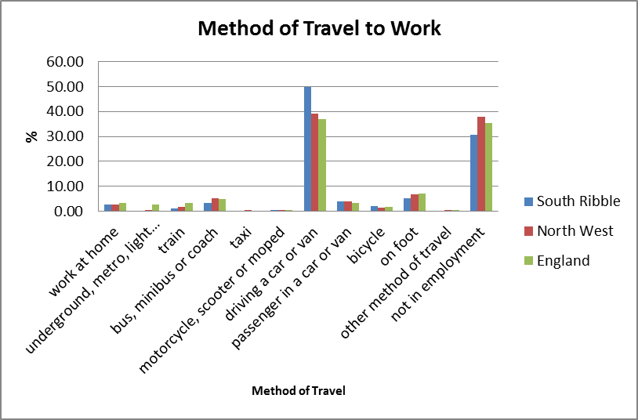

Completed development complying with car parking standards (residential and non-residential)

Policy/Policies this contributes to - B1, F1

5.24 All completed development complied with parking standards were required.

Appendix A
Meet South Ribble annual housing requirement

Policy/Policies this contributes to - D1, D2

5.25 During the 2017/18 monitoring year there were 318 dwelling completions in the borough. This is below the annual housing requirement, however the figure has risen by 68% over the previous year due to several of the City Deal sites coming forward. It is expected the annual number of completions will rise further as more of these sites from the Local Plan are brought forward for development. For more details please refer to the latest Housing Land Position Statement.

5.26 The strategic requirement for the period 2003/04 to 2017/18 was 6,255 (fifteen years at 417 dwellings). This has resulted in South Ribble having an undersupply in this period of 1,184 dwellings.

5.27 This will result in the borough having a five year supply requirement of 3923 dwellings (five years at 785 dwellings per annum).

5.28 At 31 March 2018, the borough had a gross five year supply of 3,927 dwellings. This equates to a 5.01 year land supply, including a 20% buffer and making up the shortfall within five years. It also assumes a 20% buffer is required on both the five year requirement and the backlog.

5.29 We are confident that the borough has sufficient land supply to meet the government’s requirements. At 31 March 2018, the council could demonstrate a 5.01 year supply. This assumes we make up the shortfall in the next five years and also allows for a 20% buffer as explained above. This makes it unnecessary to release any Safeguarded Land or Green Belt at this point in time. For more details please refer to the latest Housing Land Position Statement.

Net additional housing expected to come forward each year over the remaining plan period to meet the overall housing requirement. (This should take into account the previous delivery of dwellings since the start of the plan period).

Policy/Policies this contributes to – D2

5.30 Additional housing is expected to rise over the next few years due to the large sites which are now starting to come forward, several of which are now under construction. It should be noted that the inclusion of sites in the trajectory does not mean development will come forward on a site nor does it guarantee planning permission will be granted. It means, to the best of current knowledge, sites are able to deliver housing subject to other factors such as funding, the release of land and/or the provision of additional infrastructure. Any site without valid planning permission will be subject to the normal planning process.

5.31 The following housing trajectory chart relates to the current strategic requirement at 31 March 2018.
Appendix A

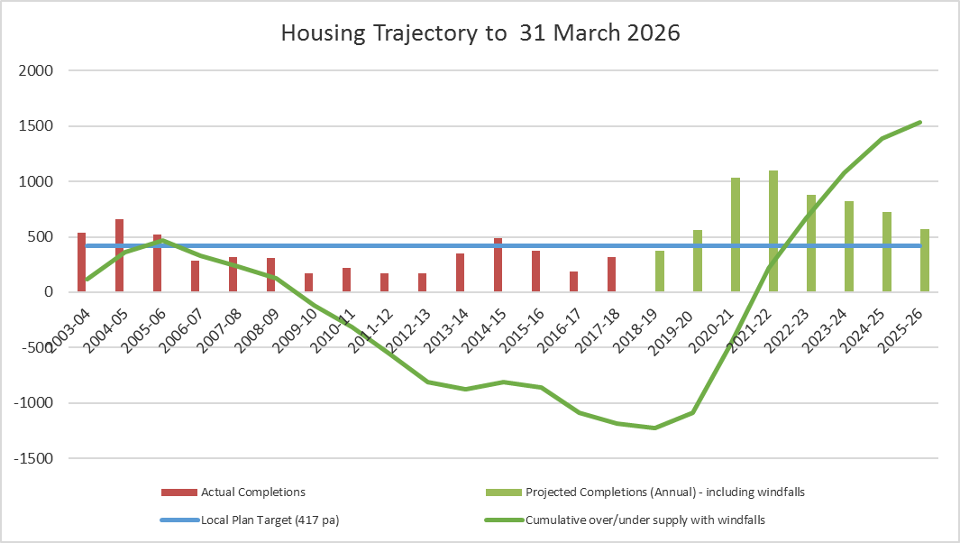
Source: SR Housing Land Position Statement 2018
For more details please refer to the latest Housing Land Position Statement.

Proportion of agricultural workers dwellings approved

Policy/Policies this contributes to - D3

5.32 Three agricultural dwellings have been approved within this monitoring period.

Proportion of A1, A3 and A4 uses in Leyland Town Centre

Policy/Policies this contributes to - E3

 | A1 | A3 | A4
Leyland Town Centre | 41% | 4% | 3%
Within Primary Retail Frontage | 51% | 4% | 6%

5.33 The Local Plan 2015 sets a target of a minimum of 60% A1 units in the primary retail frontage. This indicator reports on the amount of A1, A3 and A4 uses, which currently is below the 60% target set in the Indicator, and the target of 60% or more A1 uses set in the policy, in both the town centre and primary retail frontage.

5.34 The proportion of A1 units is currently below the target set in the policy, applications for non-A1 uses should therefore not currently be supported unless there are exceptional circumstances.
Please see the latest Retail Position Statement for more detail.

Proportion of A1, A3 and A4 uses in district centres
Appendix A

Policy/Policies this contributes to - E4

District Centre | A1 | A3 | A4
Penwortham | 44% | 8% | 1%
Bamber Bridge | 38% | 3% | 3%
Tardy Gate | 61% | 4% | 2%
Longton | 43% | 5% | 0%

5.35 Policy E4 of the Local Plan 2015 sets a target of a minimum of 60% A1 uses in the district centres. The Indicator in the Monitoring Framework has a target of the proportion of A1/A3 and A4 uses combined being more than 60%. For centres where the 60% target for A1 uses has not been met, no further applications for non-A1 uses should not be permitted unless there are exceptional circumstances.

5.36 Only one of the district centres (Tardy Gate) currently meet this target within the Monitoring Framework, with some centres being significantly below the target.
Please see the latest Retail Position Statement for more detail.

Proportion of A1, A3 and A4 uses in local centres

Policy/Policies this contributes to - E5

Local Centre | A1 | A3 | A4
Kingsfold | 34% | 2% | 2%
Earnshaw Bridge | 50% | 0% | 0%
Farington | 41% | 0% | 5%
Higher Walton | 30% | 5% | 5%
Seven Stars | 56% | 3% | 6%
Walton Le Dale | 22% | 0% | 5%
Gregson Lane | 54% | 8% | 0%
New Longton | 82% | 9% | 0%
Walmer Bridge | 39% | 6% | 6%

5.37 Policy E5 of the Local Plan 2015 sets a target of a minimum of 60% A1 uses in the local centres. The Indicator in the Monitoring Framework has a target of the proportion of A1, A3 and A4 uses combined being more than 60%.

5.38 For centres where the 60% target for A1 uses has not been met, no further applications for non-A1 uses should be permitted unless there are exceptional circumstances.

5.39 Only three of the local centres currently meet the target within the Monitoring Framework, with some centres being significantly below the target.

Vacant units in town/district/local centres
Appendix A

Policy/Policies this contributes to – B4, B5, E3, E4, E5

Retail Centres | % Vacant
Leyland Town Centre | 6%
Penwortham District Centre | 9%
Bamber Bridge District Centre | 3%
Tardy Gate District Centre | 4%
Longton District | 3%
Kingsfold Local Centre | 2%
Earnshaw Bridge Local Centre | 0%
Farington Local Centre | 14%
Gregson Lane Local Centre | 15%
Higher Walton Local Centre | 5%
New Longton Local Centre | 0%
Seven Stars Local Centre | 11%
Walmer Bridge Local Centre | 6%
Walton-le-Dale Local Centre | 5%

5.40 The table above shows that two of the centres in the Borough have a 0% vacancy rate, these are New Longton and Earnshaw Bridge. Gregson Lane has the highest rate although this is significantly down on the rate of last year. Four of the centres have seen a decrease in the vacancy rate, four centres have seen a slight increase with the rest staying the same as last year.

5.41 Leyland, Kingsfold, Walton-le-Dale and Gregson Lane have all seen a decrease in vacancy rates on last year. Whilst Penwortham, Longton, Seven Stars, Walmer - Bridge and Farington have seen an increase. Bamber Bridge, Tardy Gate, Earnshaw Bridge, Higher Walton and New Longton have stayed the same as last year.

5.42 The target of no increase in vacant units for three consecutive years within the town and district centres in the performance indicator of the Local Plan 2015 has been met. Vacancy rates will continue to be monitored in order to ensure the effectiveness of the policies. Please see the latest Retail Position Statement for more detail.

Appendix A

Percentage of Buildings in Greenbelt approved for re-use

Policy/Policies this contributes to - G2

5.43 100% of applications that met policy requirements were approved for re-use in the green belt.

Loss of trees/woodland protected by TPOs

Policy/Policies this contributes to – G13

5.44 388 tree preservation orders (TPOs) were in force in the borough as of March 2018 protecting individual or groups of trees and woodlands, this figure is higher than last year so there was no loss. However trees protected by a TPO can be removed for various reasons i.e. damaged, being structurally unsound and leaning etc.

Number of Green Flag awards for parks/green spaces in the Borough

Policy/Policies this contributes to - G7

5.45 Three of the Boroughs Parks/Green Spaces have been awarded the Green Flag award for 2017/18. This is the same as previous years so there has been no loss of the Green Flag awards.

Worden Park to maintain Green Flag status

Policy/Policies this contributes to - G9

5.46 Worden Park has maintained its Green Flag status for the 2017/18 monitoring period.

Development on unstable or contaminated land contrary to policy

Policy/Policies this contributes to - G14

5.47 There was no development on contaminated land contrary to policy in this monitoring period. Any proposals for development of this type of land would have to be in accordance with policy G14 of the Local Plan.

Development on derelict land contrary to policy

Policy/Policies this contributes to - G15

5.48 No development took place on derelict land contrary to policy in this monitoring period. Close working between the Planning Policy and Development Management teams will ensure that any future schemes on such sites are in accordance with policy G15 of the Local Plan.

Appendix A

6. Monitoring Framework

6.1 The council recognises that monitoring and review are crucial in producing an effective Local Plan. Monitoring helps measure the outputs and outcomes of policies but it also helps to establish a sound evidence base upon which polices can be developed.

6.2 The monitoring process is ongoing and integral to the Local Development Document process.

6.3 The Planning Policy team already has good monitoring systems in place and gathers information such as;

- Housing and employment land completions;
- Town/district/local centre health checks;
- Data on housing need with housing colleagues;
- Working across boundaries with other districts to understand the characteristics of the wider central Lancashire area e.g. the Core Central Lancashire sub regional strategy commissioned jointly with Preston CC and Chorley BC;
- Evidence from commissioned studies e.g. the South Ribble Retail Study (2017), the Open Space and Recreation Study (2012); Central Lancashire Employment Land Study (2017) and the Central Lancashire Strategic Housing Market Area Assessment (SHMAA) 2017.
- Maximise the use of published data e.g. from the ONS website and the Lancashire Profile website;
- Developing the Corporate Land and Property system (including GIS) to store and analyse spatial data;
- Working with Lancashire County Council to develop our monitoring information.
- Develop the evidence bases for the LDF, jointly with Preston and Chorley Councils, e.g. the Joint Employment Land Review and the Strategic Flood Risk Assessment.

